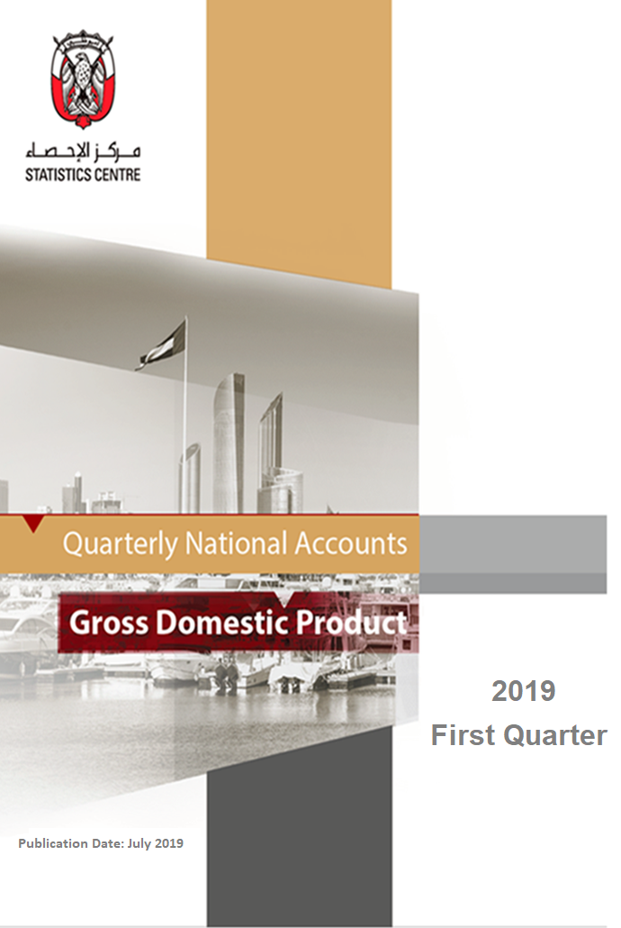

Table of Contents

Introduction ……………………………………………………………………………………...............................5
Key Economic Developments ………………………………………………………………….…….………….…6
Oil and Non-oil Gross Domestic Product at Current Prices ……………………………….. 7
Oil and Non-oil Gross Domestic Product at Constant Prices …………………………...…. 8
Gross Domestic Product by Sectors at Current Prices ……………………………..…....... 9
Gross Domestic Product by Sectors at Constant Prices……………………………….…… 12
Statistical Tables ………………………………………………………..………..…...….……. 15
Explanatory Notes…………………………………………………………………………..…… 20
Glossary of Terms and Acronyms…………………………………………..………………………………….…22
List of Tables

Table 1: Gross Domestic Product key statistics …………………………………….…...………………...……..15
Table 2: Oil and Non-oil Gross Domestic Product at current and constant prices …..…………………….…….15
Table 3: Percentage change in Oil and Non-oil Gross Domestic Product at current and constant prices…..16
Table 4: Percentage change in Oil and Non-oil Gross Domestic Product at current and constant prices .…16
Table 5: Gross Domestic Product by sectors at current prices ……….…………………………………..….….16
Table 6: Gross Domestic Product by sectors at constant 2007 prices …………………………………………..17
Table 7: Percentage change in Gross Domestic Product by sectors at current prices ……………………….17
Table 8: Percentage change in Gross Domestic Product by sectors at current prices...…………………..…17
Table 9: Percentage contribution to Gross Domestic Product by sectors at current prices ……….…….......18
Table 10: Percentage change in Gross Domestic Product by sectors at constant 2007 prices ……………..18
Table 11: Percentage change in Gross Domestic Product by sectors at constant 2007 prices ……………..18
Table 12: Percentage contribution to Gross Domestic Product by sectors at constant 2007 prices …....…..19

List of Figures

Figure 1: Percentage change in Gross Domestic Product at current and constant 2007 prices...………...……6
Figure 2: Percentage change in Gross Domestic Product at current prices ….……………………….……..…... 7
Figure 3: Percentage contribution to Gross Domestic Product at current prices, Q1 2019…..………….…..….. 8
Figure 4: Percentage change in Gross Domestic Product at constant 2007 prices ……………………................8
Figure 5: Percentage change in Gross Domestic Product by sectors at current prices …….….…….…...….….9
Figure 6: Percentage change in the ‘Non-financial’ sector at current prices ...……………..….......….....…..10
Figure 7: Percentage change in the ‘Financial companies’ sector at current prices …………………..….…….10
Figure 8: Percentage change in the ‘General government’ sector at current prices …………....…....……….11
Figure 9: Percentage change in the ‘Household’ sector at current prices ………………...……..………......… 11
Figure 10: Percentage change in Gross Domestic Product by sectors at constant 2007 prices……….…...... 12
Figure 11: Percentage change in the ‘Non-financial’ sector at constant 2007 prices ..…………...…..….….... 13
Figure 12: Percentage change in the ‘Financial companies’ sector at constant 2007 prices .......….....…….. 13
Figure 13: Percentage change in the ‘General government’ sector at constant 2007 prices.………...…..….. 14
Figure 14: Percentage change in activities of the ‘Household’ sector at constant 2007 prices…………………………………..………………………………………….…...………………..………..……...14
Introduction

This publication includes estimates of the quarterly Gross Domestic Product (GDP) at both current and constant prices for the Emirate of Abu Dhabi.
The quarterly GDP estimates in this publication are by sectors and components, including oil and non-oil sectors, and will be available as per the economic activities in revision 4 of the International Standard Industrial Classification (ISIC 4) in the future.
The quarterly GDP estimates are characterized by its need for seasonal adjustments and benchmarking against the final annual GDP results. In this publication, data that are affected by seasonal factors are adjusted to remove the effects of these factors. These statistics will remain preliminary estimates and aggregates until the quarterly series is benchmarked against the final annual GDP and seasonally adjusted. Quarterly GDP statistics in this publication were benchmarked against the final annual GDP estimates for the 2018 reference year, and the preliminary annual GDP estimates for the 2019 reference year.
Quarterly GDP at current prices measures the value of products and services produced by the economy during a given quarter after deducting the intermediate goods and services consumed as inputs in the production processes. GDP at current prices consists of two components, a price and a volume (or quantity). For a specified period, the price reflects the prices for goods and service produced while the volume reflects the quantity of the goods and services produced.

GDP estimates at constant prices remove the effect of price changes, and thus reflect the actual change in the economy. Quarterly GDP was calculated and compared with the total annual value added from the first quarter of 2012. It is a measure of the quantity of goods and services produced for that same period.

The statistical indicators in this publication are based on the results of the Quarterly Economic Survey and on data collected from various administrative sources. Quarterly percentage movements were calculated from the quarterly survey data and indicators derived from administrative data.

The Explanatory Notes section at the end of this publication defines the key terms and technical concepts used in the compilation of the quarterly GDP estimates. Readers are encouraged to refer to that section while reading the statistics and information outlined in the publication.

Key Economic Developments

All estimates are in seasonally adjusted terms.

Gross Domestic Product at current prices in the Emirate of Abu Dhabi increased by 3.3% from the first quarter of 2018 to the first quarter of 2019, while GDP at constant 2007 prices increased by 5.7% during the same period. Figure 1 shows the annual change of quarterly GDP in both current and constant 2007 prices. These movements reflect the changes in each quarter compared with the same quarter in the previous year.

Figure 1: Percentage change in Gross Domestic Product at current and constant 2007 prices, from the same quarter of the previous year

Source: Statistics Centre - Abu Dhabi

The changes in oil and non-oil Gross Domestic Product at current prices, from the first quarter of 2018 to the first quarter of 2019, were as follows:
- The value added by non-oil activities decreased by 1.6%.
- The value added by oil activities increased by 11.6%.

Gross Domestic Product at constant prices increased by 5.7% from the first quarter of 2018 to the first quarter of 2019
The changes in the oil and non-oil Gross Domestic Product were as follows:
- The value added by non-oil activities decreased by 0.9%.
- The value added by oil activities increased by 12.8%.

The changes in oil and non-oil Gross Domestic Product at current prices, from the fourth quarter of 2018 to the first quarter of 2019, were as follows:
- The value added by non-oil activities decreased by 2.9%.
- The value added by oil activities decreased by 12.5%.

Gross Domestic Product at constant prices increased by 2.0% from the fourth quarter of 2018 to the first quarter of 2019
The changes in the oil and non-oil Gross Domestic Product were as follows:
- The value added by non-oil activities decreased by 1.2%.
- The value added by oil activities increased by 5.1%.

Oil and Non-oil Gross Domestic Product at Current Prices

The GDP at current prices, for the Emirate of Abu Dhabi, increased by 3.3% in the first quarter of 2019 compared with the same quarter in 2018. This increase in economic activity could mainly be attributed to the value added by oil activities, which rose by 11.6%. At the same time, the value added by non-oil activities decreased by 1.6% following an annual growth rate of 1.6% in quarter four of 2018. The contribution of non-oil activities to total GDP at current prices decreased from 63.2% in the first quarter of 2018 to 60.2% in the first quarter of 2019.

Compared with the previous quarter, the GDP at current prices decreased by 6.9% in the first quarter of 2019. The value added by oil activities reached AED 89,918 million in Q1 2019 compared with AED 102,746 million in Q4 2018. The value added for non-oil activities reached AED 136,121 million in Q1 2019 compared to AED 140,158 million in Q1 2018.

Figure 2: Percentage change in Gross Domestic Product at current price
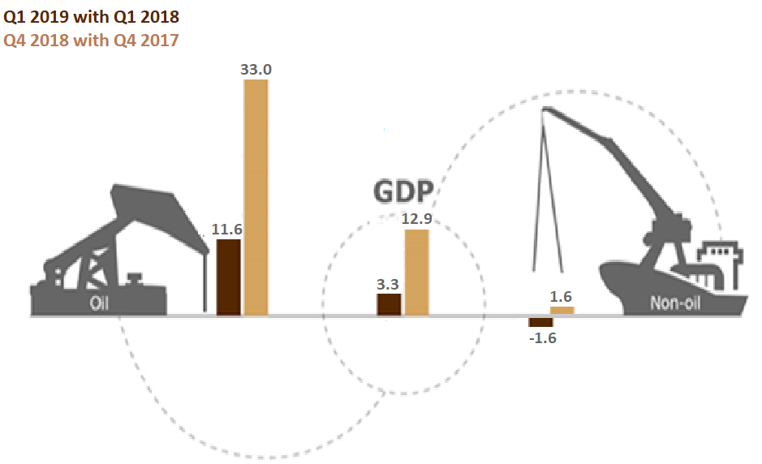
Source: Statistics Centre - Abu DhabiFigure 3: Percentage contribution to Gross Domestic Product at current prices, Q1 2019

Source: Statistics Centre - Abu Dhabi

Oil and Non-oil Gross Domestic Product at Constant Prices

GDP measured at constant prices increased by 5.7% in the first quarter of 2019, compared with the first quarter of 2018. The value added at constant prices of non-oil activities decreased by 0.9% while oil activities increased by 12.8%. As a result, the contribution of non-oil activities to total GDP at constant prices decreased from 51.7% in the first quarter of 2018 to 48.4% in the first quarter of 2019.

Compared with the previous quarter, the GDP at constant prices increased by 2.0% in the first quarter of 2019. The value added by oil activities increased by 5.1%, while the value added for non-oil activities reached AED 100,383 million in the first quarter of 2019 compared with AED 101,587 million in the fourth quarter of 2018.

Figure 4: Percentage change in Gross Domestic Product at constant 2007 price
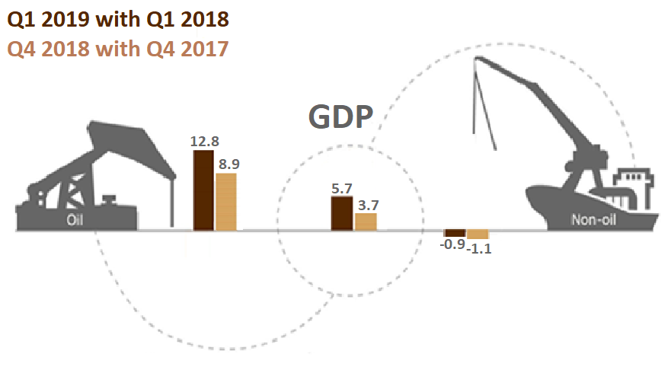
Source: Statistics Centre - Abu Dhabi
Gross Domestic Product by Sectors at Current Prices

The GDP at current prices increased by 3.3% in the first quarter of 2019, compared with the first quarter of 2018. The ‘Households’ sector increased by 7.8% from the first quarter of 2018 to the first quarter of 2019. Activities of the ‘Non-financial companies’ sector increased by 3.5%. The value added of the 'General government’ sector increased by 2.6% while the ‘Financial companies’ sector increased by 0.9% from the first quarter of 2018 to the first quarter of 2019.

Figure 5: Percentage change in Gross Domestic Product by sectors at current prices

Source: Statistics Centre - Abu Dhabi

Non-financial sector

The value added by the ‘Non-financial’ sector increased by 3.5% from AED 182,285 million in the first quarter of 2018 to AED 188,705 million in the first quarter of 2019. Its contribution to total GDP increased from 83.3% in the first quarter of 2018 to 83.5% in the first quarter of 2019.

Figure 6: Percentage change in the ‘Non-financial’ sector at current prices, from the same quarter of the previous year

Source: Statistics Centre - Abu Dhabi

Financial companies sector
The value added by the ‘Financial companies’ sector increased by 0.9% from AED 19,061 million in the first quarter of 2018 to AED 19,231 million in the first quarter of 2019. Its contribution to total GDP decreased from 8.7% in the first quarter of 2018 to 8.5% in the first quarter of 2019.

Figure 7: Percentage change in the ‘Financial companies’ sector at current prices, from the same quarter of the previous year

Source: Statistics Centre - Abu Dhabi

General government sector
The value added by the ‘General government’ sector increased by 2.6% from AED 16,102 million in the first quarter of 2018 to AED 16,519 million in the first quarter of 2019. Its contribution to total GDP decreased from 7.4% to 7.3% over the same period.

Figure 8: Percentage change in the ‘General government’ sector at current prices, from the same quarter of the previous year

Source: Statistics Centre - Abu Dhabi

Household sector
The value added by the ‘Household’ sector increased by 7.8% from AED 1,470 million in the first quarter of 2018 to AED 1,585 million in the first quarter of 2019. Its contribution to total GDP remained at 0.7% over the period.

Figure 9: Percentage change in the ‘Household’ sector at current prices, from the same quarter of the previous year

Source: Statistics Centre - Abu Dhabi
Gross Domestic Product by Sectors at Constant prices

The GDP at constant prices increased by 5.7% in the first quarter of 2019, compared with the first quarter of 2018. The value added of the ‘General government’ sector increased by 0.1% in the first quarter of 2019, compared with the same quarter in the previous year. Value added by the ‘Household’ sector increased by 3.1% from the first quarter of 2018 to the first quarter of 2019, while the ‘Non-financial’ sector increased by 6.7% in the first quarter of 2019 compared with the same quarter in 2018. Over the same period, the value added by the ‘Financial companies’ sector decreased by 2.4%.

Figure 10: Percentage change in Gross Domestic Product by sectors at constant 2007 prices

%

Source: Statistics Centre - Abu Dhabi

Non-financial sector
In recent quarters, the estimates for the non-financial sector have shown an increase compared with the same quarter in the previous year. The value added by the ‘Non-financial’ sector rose by 6.7% from AED 172,722 million in the first quarter of 2018 to AED 184,228 million in the first quarter of 2019. Its contribution to total GDP increased from 88.1% to 88.9% over the same period.

Figure 11: Percentage change in the ‘Non-financial’ sector at constant 2007 prices, from the same quarter of the previous year

Source: Statistics Centre - Abu Dhabi

Financial companies sector
The value added by the ‘Financial companies’ sector decreased by 2.4% from AED 14,470 million in the first quarter of 2018 to AED 14,125 million in the first quarter of 2019. Its contribution to total GDP was 6.8% in the first quarter of 2019 compared with 7.4% in the first quarter of 2018.

Figure 12: Percentage change in the ‘Financial companies’ sector at constant 2007 prices, from the same quarter of the previous year

Source: Statistics Centre - Abu Dhabi

General government sector
The value added by the ‘General government’ sector increased by 0.1% from AED 7,756 million in the first quarter of 2018 to AED 7,763 million in the first quarter of 2019. Its contribution to total GDP was 3.7% in the first quarter of 2019 compared with 4.0% in the same quarter of 2018.
Figure 13: Percentage change in the ‘General government’ sector at constant 2007 prices, from the same quarter of the previous year

Source: Statistics Centre - Abu Dhabi

Household sector
The value added by the ‘Household’ sector increased by 3.1% from AED 1,043 million in the first quarter of 2018 to AED 1,075 million in the first quarter of 2019. Its contribution to total GDP remained at 0.5% over the same period.

Figure 14: Percentage change in activities of the ‘Household’ sector at constant 2007 prices, from the same quarter of the previous year

Source: Statistics Centre - Abu Dhabi

Statistical Tables
Table 1: Gross Domestic Product key statistics*
Production measure  Seasonally adjusted | Q2 2017 | Q3 2017 | Q4 2017 | Q1 2018 | Q2 2018 | Q3 2018 | Q4 2018 | Q1 2019
GDP at current prices (million AED) | 196,833 | 201,523 | 215,196 | 218,918 | 231,665 | 237,547 | 242,904 | 226,039
Oil value added at current prices (million AED) | 64,614 | 67,110 | 77,252 | 80,604 | 92,331 | 100,254 | 102,746 | 89,918
Oil value added at current prices (% contribution to total) | 32.8 | 33.3 | 35.9 | 36.8 | 39.9 | 42.2 | 42.3 | 39.8
Non-oil value added at current prices (million AED) | 132,219 | 134,414 | 137,944 | 138,314 | 139,335 | 137,293 | 140,158 | 136,121
Non-oil value added at current prices (% contribution to total) | 67.2 | 66.7 | 64.1 | 63.2 | 60.1 | 57.8 | 57.7 | 60.2
GDP at constant 2007 prices (million AED) | 195,177 | 195,233 | 195,939 | 195,991 | 199,342 | 198,759 | 203,186 | 207,192
Oil value added at constant 2007 prices (million AED) | 94,884 | 93,880 | 93,269 | 94,655 | 96,075 | 98,426 | 101,598 | 106,809
Oil value added at constant 2007 prices (% contribution to total) | 48.6 | 48.1 | 47.6 | 48.3 | 48.2 | 49.5 | 50.0 | 51.6
Non-oil value added at constant 2007 prices (million AED) | 100,292 | 101,353 | 102,670 | 101,336 | 103,267 | 100,334 | 101,587 | 100,383
Non-oil value added at constant 2007 prices (% contribution to total) | 51.4 | 51.9 | 52.4 | 51.7 | 51.8 | 50.5 | 50.0 | 48.4

Source: Statistics Centre - Abu Dhabi
*Preliminary estimates

Table 2: Oil and Non-oil Gross Domestic Product at current and constant prices*
Value in million AED
Production measure  Seasonally adjusted | Q2 2017 | Q3 2017 | Q4 2017 | Q1 2018 | Q2 2018 | Q3 2018 | Q4 2018 | Q1 2019
Oil value added at current prices | 64,614 | 67,110 | 77,252 | 80,604 | 92,331 | 100,254 | 102,746 | 89,918
Non-oil value added at current prices | 132,219 | 134,414 | 137,944 | 138,314 | 139,335 | 137,293 | 140,158 | 136,121
GDP at current prices | 196,833 | 201,523 | 215,196 | 218,918 | 231,665 | 237,547 | 242,904 | 226,039
Oil value added at constant 2007 prices | 94,884 | 93,880 | 93,269 | 94,655 | 96,075 | 98,426 | 101,598 | 106,809
Non-oil value added at constant 2007 prices | 100,292 | 101,353 | 102,670 | 101,336 | 103,267 | 100,334 | 101,587 | 100,383
GDP at constant 2007 prices | 195,177 | 195,233 | 195,939 | 195,991 | 199,342 | 198,759 | 203,186 | 207,192

Source: Statistics Centre - Abu Dhabi
*Preliminary estimates
Table 3: Percentage change in Oil and Non-oil Gross Domestic Product at current and constant prices*
Percentage change from the same quarter of the previous year
Production measure  Seasonally adjusted | Q1 2018 | Q2 2018 | Q3 2018 | Q4 2018 | Q1 2019
Oil value added at current prices | 18.4 | 42.9 | 49.4 | 33.0 | 11.6
Non-oil value added at current prices | 4.8 | 5.4 | 2.1 | 1.6 | -1.6
GDP at current prices | 9.4 | 17.7 | 17.9 | 12.9 | 3.3
Oil value added at constant 2007 prices | -1.4 | 1.3 | 4.8 | 8.9 | 12.8
Non-oil value added at constant 2007 prices | 1.4 | 3.0 | -1.0 | -1.1 | -0.9
GDP at constant 2007 prices | 0.0 | 2.1 | 1.8 | 3.7 | 5.7

Source: Statistics Centre - Abu Dhabi
*Preliminary estimates

Table 4: Percentage change in Oil and Non-oil Gross Domestic Product at current and constant prices*
Percentage change from the previous quarter
Production measure  Seasonally adjusted | Q1 2018 | Q2 2018 | Q3 2018 | Q4 2018 | Q1 2019
Oil value added at current prices | 4.3 | 14.5 | 8.6 | 2.5 |  | -12.5
Non-oil value added at current prices | 0.3 | 0.7 | -1.5 | 2.1 |  | -2.9
GDP at current prices | 1.7 | 5.8 | 2.5 | 2.3 |  | 6.9-
Oil value added at constant 2007 prices | 1.5 | 1.5 | 2.4 | 3.2 |  | 5.1
Non-oil value added at constant 2007 prices | -1.3 | 1.9 | -2.8 | 1.2 |  | -1.2
GDP at constant 2007 prices | 0.0 | 1.7 | -0.3 | 2.2 |  | 2.0

Source: Statistics Centre - Abu Dhabi
*Preliminary estimates

Table 5: Gross Domestic Product by sectors at current prices*
Value in million AED
Sector  Seasonally adjusted | Q2 2017 | Q3 2017 | Q4 2017 | Q1 2018 | Q2 2018 | Q3 2018 | Q4 2018 | Q1 2019
Non-financial | 161,941 | 166,295 | 178,628 | 182,285 | 193,022 | 202,285 | 204,213 | 188,705
Financial companies | 18,406 | 18,684 | 18,912 | 19,061 | 20,952 | 17,288 | 20,620 | 19,231
General government | 15,108 | 15,136 | 16,219 | 16,102 | 16,193 | 16,448 | 16,519 | 16,519
Households | 1,378 | 1,408 | 1,437 | 1,470 | 1,498 | 1,525 | 1,552 | 1,585
GDP | 196,833 | 201,523 | 215,196 | 218,918 | 231,665 | 237,547 | 242,904 | 226,039

Source: Statistics Centre - Abu Dhabi
*Preliminary estimates

Table 6: Gross Domestic Product by sectors at constant 2007 prices*
Value in million AED
Sector  Seasonally adjusted | Q2 2017 | Q3 2017 | Q4 2017 | Q1 2018 | Q2 2018 | Q3 2018 | Q4 2018 | Q1 2019
Non-financial | 172,281 | 171,655 | 172,306 | 172,722 | 174,595 | 177,049 | 179,524 | 184,228
Financial companies | 14,162 | 14,614 | 14,640 | 14,470 | 15,878 | 12,807 | 14,814 | 14,125
General government | 7,739 | 7,951 | 7,962 | 7,756 | 7,818 | 7,846 | 7,785 | 7,763
Households | 995 | 1,013 | 1,031 | 1,043 | 1,051 | 1,057 | 1,063 | 1,075
GDP | 195,177 | 195,233 | 195,939 | 195,991 | 199,342 | 198,759 | 203,186 | 207,192

Source: Statistics Centre - Abu Dhabi
*Preliminary estimates

Table 7: Percentage change in Gross Domestic Product by sectors at current prices*
Percentage change from the same quarter of the previous year
Sector  Seasonally adjusted | Q1 2018 | Q2 2018 | Q3 2018 | Q4 2018 | Q1 2019
Non-financial | 10.3 | 19.2 | 21.6 | 14.3 | 3.5
Financial companies | 2.8 | 13.8 | -7.5 | 9.0 | 0.9
General government | 8.1 | 7.2 | 8.7 | 1.8 | 2.6
Households | 9.0 | 8.7 | 8.3 | 8.0 | 7.8
GDP | 9.4 | 17.7 | 17.9 | 12.9 | 3.3

Source: Statistics Centre - Abu Dhabi
*Preliminary estimates

Table 8: Percentage change in Gross Domestic Product by sectors at current prices*
Percentage change from the previous quarter
Sector  Seasonally adjusted | Q1 2018 | Q2 2018 | Q3 2018 | Q4 2018 | Q1 2019
Non-financial | 2.0 | 5.9 | 4.8 | 1.0 | -7.6
Financial companies | 0.8 | 9.9 | -17.5 | 19.3 | -6.7
General government | -0.7 | 0.6 | 1.6 | 0.4 | 0.0
Households | 2.3 | 1.9 | 1.8 | 1.8 | 2.1
GDP | 1.7 | 5.8 | 2.5 | 2.3 | -6.9

Source: Statistics Centre - Abu Dhabi
*Preliminary estimates

Table 9: Percentage contribution to Gross Domestic Product by sectors at current prices*
(%)
Sector  Seasonally adjusted | Q2 2017 | Q3 2017 | Q4 2017 | Q1 2018 | Q2 2018 | Q3 2018 | Q4 2018 | Q1 2019
Non-financial | 82.3 | 82.5 | 83.0 | 83.3 | 83.3 | 85.2 | 84.1 | 83.5
Financial companies | 9.4 | 9.3 | 8.8 | 8.7 | 9.0 | 7.3 | 8.5 | 8.5
General government | 7.7 | 7.5 | 7.5 | 7.4 | 7.0 | 6.9 | 6.8 | 7.3
Households | 0.7 | 0.7 | 0.7 | 0.7 | 0.6 | 0.6 | 0.6 | 0.7
GDP | 100 | 100 | 100 | 100 | 100 | 100 | 100 | 100

Source: Statistics Centre - Abu Dhabi
*Preliminary estimates
Note: Totals may not add to 100 due to rounding.

Table 10: Percentage change in Gross Domestic Product by sectors at constant 2007 prices*
Percentage change from the same quarter of the previous year
Sector  Seasonally adjusted | Q1 2018 | Q2 2018 | Q3 2018 | Q4 2018 | Q1 2019
Non-financial | -0.3 | 1.3 | 3.1 | 4.2 | 6.7
Financial companies | 3.3 | 12.1 | -12.4 | 1.2 | 2.4-
General government | 1.6 | 1.0 | -1.3 | -2.2 | 0.1
Households | 7.2 | 5.7 | 4.4 | 3.1 | 3.1
GDP | 0.0 | 2.1 | 1.8 | 3.7 | 5.7

Source: Statistics Centre - Abu Dhabi
*Preliminary estimates

Table 11: Percentage change in Gross Domestic Product by sectors at constant 2007 prices*
Percentage change from the previous quarter
Sector  Seasonally adjusted | Q1 2018 | Q2 2018 | Q3 2018 | Q4 2018 | Q1 2019
Non-financial | 0.2 | 1.1 | 1.4 | 1.4 | 2.6
Financial companies | -1.2 | 9.7 | -19.3 | 15.7 | 4.6-
General government | -2.6 | 0.8 | 0.4 | 0.8- | 0.3-
Households | 1.2 | 0.8 | 0.6 | 0.6 | 1.1
GDP | 0.0 | 1.7 | -0.3 | 2.2 | 2.0

Source: Statistics Centre - Abu Dhabi
*Preliminary estimates

Table 12: Percentage contribution to Gross Domestic Product by sectors at constant 2007 prices*
(%)
Sector  Seasonally adjusted | Q2 2017 | Q3 2017 | Q4 2017 | Q1 2018 | Q2 2018 | Q3 2018 | Q4 2018 | Q1 2019
Non-financial | 88.3 | 87.9 | 87.9 | 88.1 | 87.6 | 89.1 | 88.4 | 88.9
Financial companies | 7.3 | 7.5 | 7.5 | 7.4 | 8.0 | 6.4 | 7.3 | 6.8
General government | 4.0 | 4.1 | 4.1 | 4.0 | 3.9 | 3.9 | 3.8 | 3.7
Households | 0.5 | 0.5 | 0.5 | 0.5 | 0.5 | 0.5 | 0.5 | 0.5
GDP | 100 | 100 | 100 | 100 | 100 | 100 | 100 | 100

Source: Statistics Centre - Abu Dhabi
*Preliminary estimates
Note: Totals may not add to 100 due to rounding.

Explanatory Notes

Technical notes
Compilation framework
The statistics in this publication have been compiled using the System of National Accounts 1993 international framework.
Economic territory
The statistical boundary covers all economic activity of institutional units resident to the Emirate of Abu Dhabi. Activity of units that are not resident to the Emirate of Abu Dhabi is excluded. However, many units in the UAE whether resident or non-resident to Abu Dhabi Emirate have branches across multiple emirates. This can lead to difficulties in collecting Abu Dhabi-only data, particularly when the head office is located in another emirate. SCAD is working towards implementing new collection strategies that will minimize the impact of this issue on the national accounts.
Data sources
The main data source for the current price series is the SCAD Quarterly Economic Survey (QES). However many other data sources have been used to supplement the survey data in order to best compile the statistical estimates. Other data sources include, but are not limited to, government financial data; administrative data from other Government and non-government entities; international commodity prices; and other international statistical agency data.

Constant price methodology
The constant price statistics have been calculated using different methodologies to remove the price effect and observe actual growth. The two methods used are price deflation and volume extrapolation. Price deflation requires that a current price series be divided by a price deflator series; this creates a constant price series. Volume extrapolation requires a current price series and a volume indicator series. This method applies the growth rates of the volume indicator series to the current price series in the base year to create a constant price series.

Valuation
The value added series is derived at basic prices. This means Value Added Tax (VAT) is excluded and subsidies on products are included.

Reference and base year 2007
The quarterly GDP estimates for all reference years are benchmarked against the annual GDP. As a result, the sum of the GDP for the four quarters of each year are equal to the annual GDP for the same year. The annual constant price series, which is the benchmark for the calculation of the quarterly GDP series, has a reference and base year of 2007.

Survey frame update
The economic surveys performed by SCAD are based on a comprehensive unit record data frame maintained by SCAD. This register is used in the selection and weighting of surveyed establishments. In 2010, SCAD undertook a large-scale project to update the frame; a newly updated framework has been completed and used for the annual economic survey 2009. The register is updated on a quarterly basis with administrative information collected from Abu Dhabi Government entities. The QES is a purposive sample, which includes key establishments in each activity from the 2017 Annual Economic Survey.

Revisions policy
Normal international practice in producing and continuously improving the quality of official statistics is to make revisions over time, as significant new evidence becomes available to official statistical agencies.

Quarterly estimates of GDP are released on the following schedule: “Preliminary” estimates, based on source data that are incomplete or subject to further revision by the source agency, are released near the end of the first month after the end of each quarter. No further updates are incorporated into the quarterly GDP until the benchmarking against the annual GDP (preliminary and final).

The quarterly GDP preliminary estimates for the preceding 2 years are updated as part of the benchmarking against the preliminary annual GDP estimate in March of each year. This include revisions as a result of the benchmarking exercise as well as to incorporate significant new data, which may become available. Quarterly GDP estimates for the preceding 2 calendar years are also revised during December of each year as part of the benchmarking against the final annual GDP. Final annual GDP estimates for the previous calendar year are released towards the end of October as more detailed and more comprehensive data based on primary sources become available.

Further revisions to quarterly estimates of GDP are required periodically to align the quarterly estimates with the annual estimates of GDP. These revisions are necessary to incorporate definition and classification changes or to reflect the introduction of new and improved methodologies.

Seasonal adjustment
Seasonal adjustment of the Gross Domestic Product (GDP) allows a timely assessment of the current economic conditions and identification of turning points in the economy. In this publication, data that are affected by seasonal factors are adjusted to remove the effects of these factors. All estimates are in seasonally adjusted terms.

Seasonal factors consists of events that are reasonably stable with respect to timing, direction and magnitude. These regular and predictable changes in a time series recur every calendar year. For example due to natural conditions such as seasonal changes, high temperatures during summer cause an increase in the use of chilled air which in turn result in higher electricity consumption and production compared with the cooler months of the year.
Future publications
Quarterly GDP data for the Emirate of Abu Dhabi will be released within three months after the end of the reference period.

Glossary of Terms and Acronyms

Household sector: Includes the activities of households as employers of domestic personnel such as house cleaners, cooks, waiters, valets, gardeners, gatekeepers, chauffeurs, caretakers, babysitters etc.

AED: Arab Emirates Dirham
Constant prices: This refers to the series, which have been obtained by removing the effect of price changes over time from the values of flows or stocks of goods and services.
Current prices: This refers to the series being valued at the prices current at the time the activity takes place.

Financial companies sector: Includes all establishments whose principal activity is financial intermediation or insurance related.

Gross Domestic Product (GDP): This refers to the market value of all final goods and services produced within a country in a given period. Alternatively, it can be described as the total value added of Economic activity.

Non-financial sector: The non-financial sector includes establishments whose principal activity is the production of market goods or non-financial services.

Non-oil activities: This refer to all activities with the only exception being mining and quarrying (including crude oil and natural gas).

Oil activities: This refers to the Mining and quarrying (including crude oil and natural gas) activity only. This does not include related crude oil and natural gas activities such as refining, petrochemicals, distribution, or transport.

Percentage change: Year on year percentage change or percentage change from the previous quarter.

Percentage contribution: Relative importance of a sector within the total GDP compared with other sectors.

Preliminary estimates: Estimates that have been calculated using only secondary data sources and methods. Users of this data should be aware that preliminary estimates will be revised when primary data sources become available for that time period.

Production measure of GDP: Production less intermediate consumption.

General government sector: This sector includes activities of a governmental nature, normally carried out by the public administration. It also includes compulsory social security activities.

QES: Quarterly Economic Survey.

Value added: Gross value added is the value of output less the value of intermediate consumption; it is a measure of the contribution to GDP made by an individual producer, industry or sector.

More information
For more information about the GDP and other official statistics for the Emirate of Abu Dhabi, please visit the statistics link on the SCAD website at http://www.scad.gov.abudhabi

Disclaimer
While all care and diligence has been taken with the compilation of official statistics, The Statistics Centre–Abu Dhabi gives no warranty that the information, data or statistics, supplied are free of errors. SCAD shall not be liable for any loss or damage suffered by the user following the direct or indirect use of the statistics supplied in good faith by SCAD. Users of Official Statistics are responsible for determining when and how to use the statistics for specific purposes.

